Minutes of March 2018 Meeting
Date: 3/14/18
Location: Talbot Center
Meeting called to order at 18:58 by Tom Deam, President

Roll Call of Officers and Companies: All Officers except the Secretary were present, Assistant Secretary present. All Companies except Station 40 were present.

Reading of minutes: Motion was made to have February meeting minutes to stand as written. The motion was seconded. Approved by Roll Call vote, Station 40 not present

Introduction of Guests

- Brian LeCates, Acting Director of Talbot County Emergency Services: FY 2018 Budget submitted, now awaiting Council action. Expect to learn Council decisions in late April or early May. Two “Safe Stations” established, one at the 911 Center and the second at the St Michael’s Police Station.

- Ed Mulliken, President ESVFA: Memorial Service will be on May 20 in Oxford. Make sure you get your deceased members name in through your delegate. The Association is working to develop another training opportunity like that done in 2017. More on this as plans develop.

- Richard Smith, Member of the Executive Committee MSFA: Richard discussed the current Maryland Legislative Session. Additionally he discussed MSFA’s Third Annual Hope Awareness 5k Walk to be held in Annapolis on April 22. For more information, go to the MSFA Web Site.

Committees:

Chief’s Committee. Report by John Harris of Station 60:
- The Committee is developing a RIT Team SOP for the County. The first arriving Rescue Truck will normally be assigned as the RIT.
- They are working with Larry to inventory the Foam trailer. We do not have the agreed to amounts of each type of foam. He needed clarification of remaining Foam budget. Purchases to correct inventory short falls could be spread over this and the new Fiscal Year rather then going back to the companies for additional money.
- The State Wide Open House will be held on 15 April.

Budget Committee: Tom thanked John Hanes and the other members of the FY18 Budget Committee for their work and released them. He then asked our Treasurer, Mary Binseed to establish the FY 19 Budget Committee.

By-laws committee. The Committee presented their Draft Changes to the By-laws (Attachment 1). After review several typographic changes were noted. All members of the Executive Committee present voted to take the proposed changes to their Companies and to be prepared to vote on them at our April meeting. Station 40 was not present.

Emergency Services Board: Steve Mroczek reported that the Board had met with Council on January 23 to discuss budget, R&R, School Safety and other issues. They are currently working on a research tasks related to the utilization of the Health Sciences Lab at Chesapeake College and another on Sherriff’s Department and TCDES turnover and recruiting.

Golf Tournament: Committee: We have received our first team registration and an additional Hole Sponsorship from J & J Custom Trim Work.

Facebook Committee: Vicky Thornton from Station 50 was introduced as a member who will be helping with Facebook content.

Hall of Fame Committee: No report

Recruitment & Retention: Nothing to report.

Treasurer’s Report: $8,962.53 in checking account. Have a CD of $14,419.99. Bills: $808.99 from Graves Uniforms for badges and $159,50 to Talbot County Public Schools for Janitorial Services. This bill will be submitted to Talbot County for payment. Motion made to pay the bill was approved by roll call with Station 40 not present.

Secretary’s report: January and February Minutes have been uploaded to the Web Site

New Business: The Traveling Vietnam Memorial Wall will be at the Easton VFW May 31 through 6 June. The Chief’s Committee met with Capt Judy Mitcheliche to discuss support for the event. Planning for fire company participation still in the early phases.

Good of the Association
  - 20: Oxford Day will be 4/28
  - 30: Soup day 5:00 to be on 3/19
  - 40: Not Present
  - 50: Friday 3/16 having another concert at station.
  - 60: Easton having 5k race 4/7 looking for sponsors
  - 70: Spring dance on 4/28 music by Off the Hook.
  - 80: 3/17 11:00 Texas Hold’em. Doors open at 11:00 play starting at 1:00 Admission fee $75.
4/8 12 – 4 PM Country Ham Dinner

Motion to adjourn: Motion by 50 and seconded by 20. Meeting adjourned.

Next Meeting will be dinner meeting on April 11 at Station 30

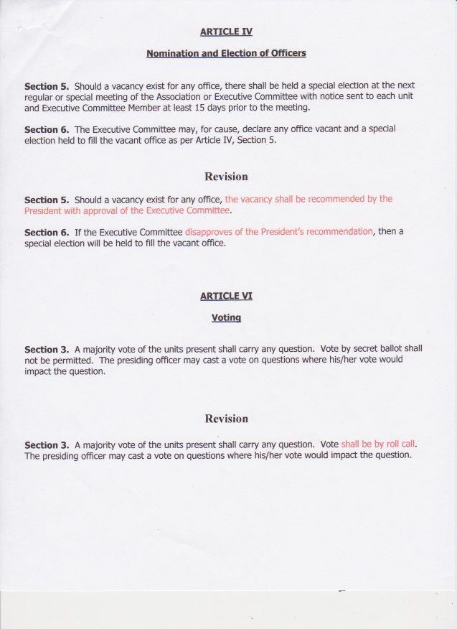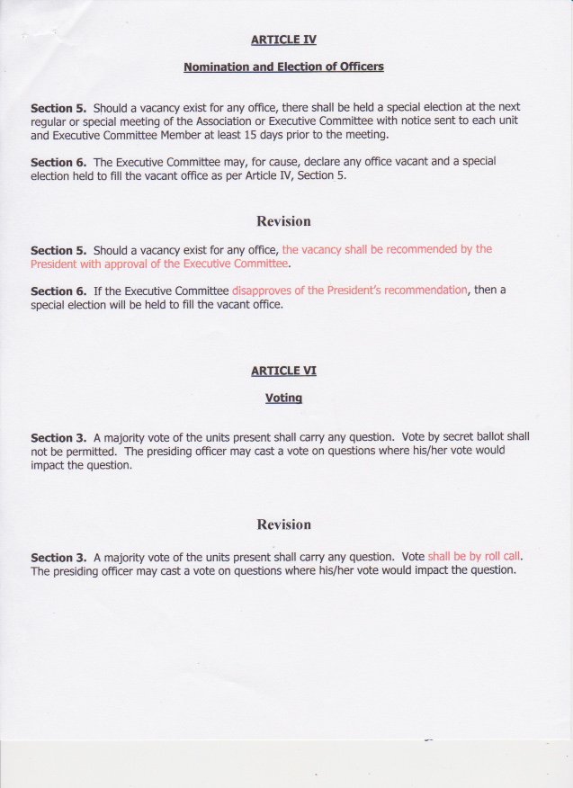
Attachment 1

